Newsletter -Summer 2025
Welcome to the latest issue of our Practice Newsletter. In this Newsletter, we aim to provide patients with up to date news, changes to the services we provide and useful information
Staffing News!!
We would like to extend a warm welcome to the following new staff members:
Victoria - Advanced Clinical Practitioner

Sarah - Patient Coordinator
Abbie – Patient Coordinator


We also say happy retirement to Carole Beckett our Practice Nurse who is hanging up her uniform after working at Ash Grove for seven years and has been working for the NHS for over 50 years!!!!

We have also celebrated Liz Fox’s 25th year of employment with Ash Grove Medical. We are sure you will agree it is a milestone worth celebrating.
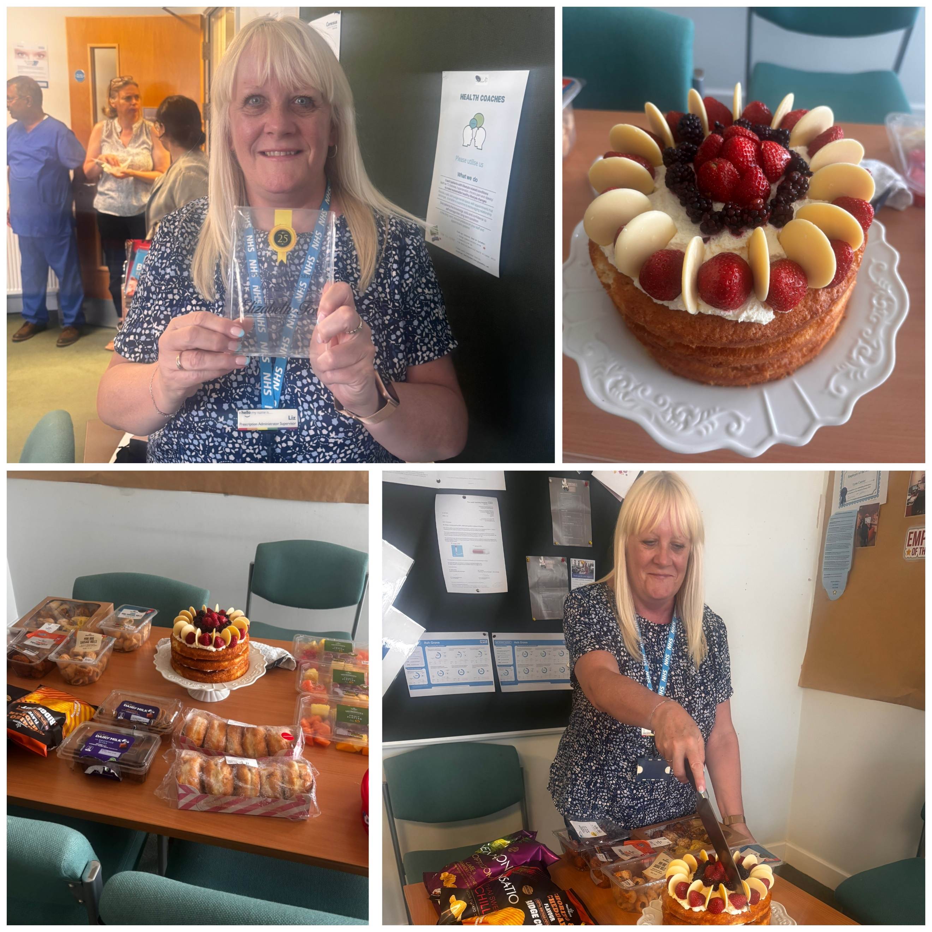

Exciting News!!
We are proud to share some exciting news – our practice has officially been approved as a Training Practice! This means we will now be helping to train the next generation of doctors by supporting qualified medical professionals who are undergoing specialist GP training.

You may meet with our GP Registrar, who is a fully qualified doctor gaining experience in general practice under the supervision of our experienced GP team. This is a fantastic step forward for our practice and reflects our commitment to high standards of care, education and continuous improvement.

Training practices are thoroughly assessed to ensure they provide safe, supportive and high quality environments for both patients and trainees – we are delighted to be recognised as one of them!

Statistics

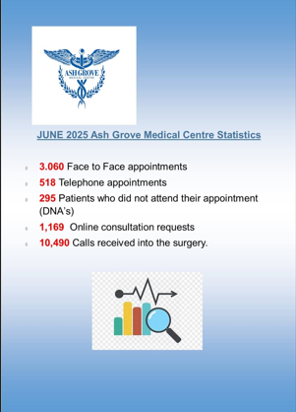
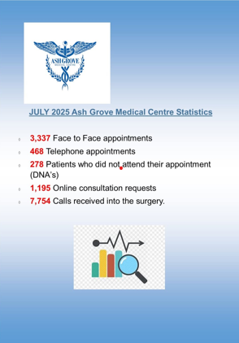
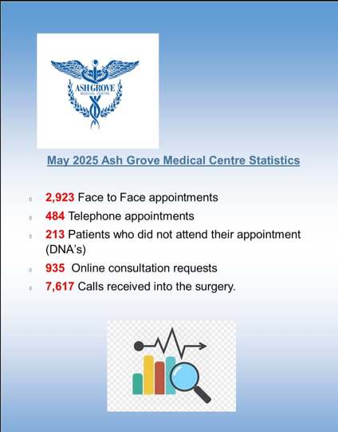

Friends and family
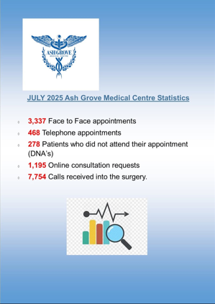
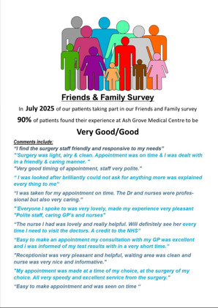

Think Pharmacy First
Hayfever season is here!!!
Many people can manage symptoms with over the counter treatments from Pharmacists without needing to see a GP. For advice on managing hayfever and when to seek help, visit https://www.nhs.uk/conditions/hayfever
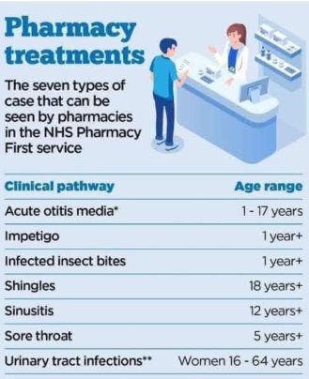

Stay safe in the heat
Tips for coping in the hot weather
If you have to go outside, stay in the shade especially between 11am and 3pm, wear sunscreen, a hat and light clothes, and avoid exercise or activity that makes you hotter.
Cool yourself down. Have cold food and drinks, avoid alcohol, caffeine and hot drinks, and have a cool shower or put cool water on your skin or clothes.
Keep your living space cool. Close windows during the day and open them at night when the temperature outside has gone down.
For more information visit: https://www.gov.uk/government/publications/beat-the-heat-hot-weaher-advice/beat-the-heat-staying-safe-in-hot-weather
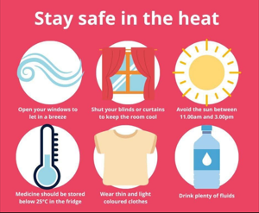

Mounjaro
Mounjaro is being introduced gradually across the NHS and is currently only available to a small number of patients who meet strict clinical criteria following a clinical assessment. There’s no need to contact the practice - if you are eligible, your GP practice or the NHS will contact you directly. Reception staff are not able to offer assessments or provide further information about eligibility, so please wait to be contacted if this treatment is appropriate for you." We understand that it may feel frustrating or disappointing if you're not eligible for Mounjaro at this time - even if you’ve been hoping for this kind of support. Please know that other help is available, and we are committed to offering compassionate, personalised care to everyone who needs it.
Cervical Screening
Cervical Screening Changes – from 1 July 2025
Big news for cervical screening in England! Starting 1 July 2025, the routine screening schedule is changing. Here’s what you need to know:
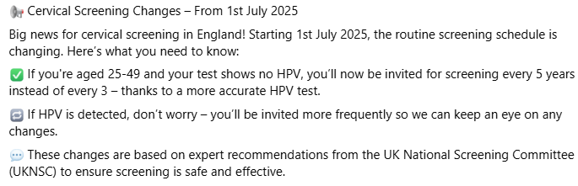
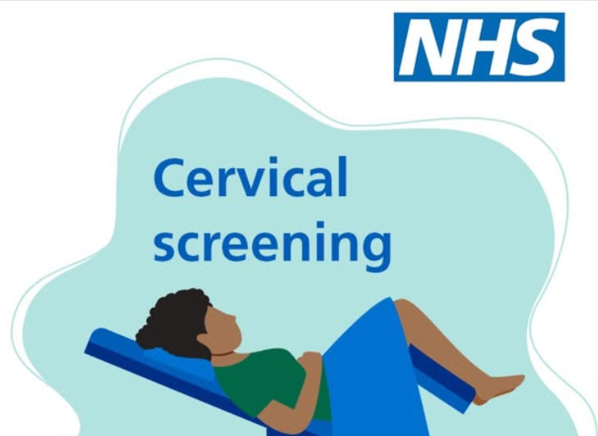

Suicide Awareness Training
Please use the link below. The suicide awareness training is a short, free, online course that can be taken by anyone who wants to learn basic suicide awareness and prevention skills.
We believe suicide is preventable and we know that sometimes all it takes to save a life is a conversation.
The training is aimed at anyone aged 16 and over who wants to know what to do if they’re ever in a situation where someone they know or see may be struggling with thoughts of suicide.
https://www.zerosuicidealliance.com/suicide-awareness-training

Here for you
Struggling with mental mental? Here for you is a free out of hours mental health support service available everyday from 6pm to midnight!
Here For You provides:
• Free, confidential, 1:1 mental health support (in person or by phone)
• A safe social space with practical support, including games, chat, mindfulness, and social activities (available 8pm–midnight)
• Rapid access without the need for a GP referral or fixed address
• Support for individuals dealing with mental health crises, self-harm, suicidal thoughts, or overwhelming feelings
• A taxi service for those who need assistance with transport
• www.touchstonesupport.org.uk/hereforyou or call 07776 962 815. You can self-refer independently or with clinician support
•Patients can self-refer online at any time and will be contacted within 24 hours
Important Notes:
•Here For You operates 7 days a week, 365 days a year, with no waiting list or need for a professional referral
•This service is available to anyone aged 16+ who may be feeling low, anxious, or experiencing thoughts of self-harm.
•Translation services are currently unavailable at the point of contact.

Join Ash Grove Medical Centre’s Patient Participation Group (PPG) – Your Voice Matters!
Everyone is welcome to be part of a diverse group that helps shape the future of healthcare at Ash Grove Medical Centre
Why Join?
- Have your say – contribute to decisions about your healthcare
- Shape the future – help improve services for all patients
- Connect and engage – meet your healthcare professionals and fellow PPG members
- Share your input – provide feedback and insights based on yours and fellow patients’ experiences
What to expect
- Open discussions and networking sessions
- A welcoming space for all ages, backgrounds
- Regular meetings attended by GPs, managers and patient representatives like you
How to get involved
- Sign up – leave your details with reception
- Contact us via email – wyicb-wak.ashgrove.admin@nhs.net
Join today!!
Please note this is not a group for own personal discussion – this is to improve the surgery
Staff Training Days
Please make a note of the dates below when the surgery will close at 12.00pm for staff training. We will close at 12 noon on the day of training and re-open the following day at 8.00am. If you need a doctor in an emergency, please telephone NHS111.
17 September 2025 15 October 2025 12 November 2025

14 January 2026 11 February 2026 11 March 2026
Flu vaccines
We are busy organising the 2025/26 flu vaccines. From September, pregnant women and children aged 2-3 years will be contacted to arrange their vaccines. All other eligible patients will be contacted to book in from October onwards. Please support your GP Practice by attending for your vaccination, as we have to purchase these vaccines in advance on your behalf.



